**CCNA Lab Test**

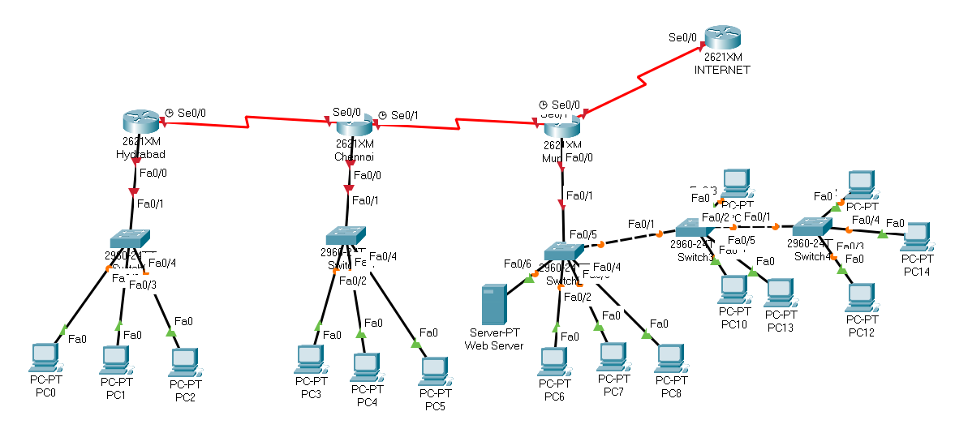

Task to perform:

1. Rename all Routers
2. Provide ip to all interfaces on the Router
3. Configure OSPF routing
4. Block pc 192.168.1.2 to use web server on 192.168.3.100
5. Network 192.168.2.0 should not have access to internet but should have to all other networks.
6. All devices should be discoverable via lldp
7. Create vlan 10,20,30 on all switches connected to Mumbai router.
8. Configure Middle switch in the Mumbai router on transparent mode
9. Configure pcs to respective vlan in the switches connected to Mumbai router.
10. All the vlans should be able to communicate to each other.
11. All the switches on all routers should be configured with portfast on the port connected to end devices.
12. The pc connected to Hydrabad router should be configured with NAT with static Public IP 2.2.2.1, 2.2.2.2, 2.2.2.3 facing towards internet.
13. All the routers should have telnet connectivity from everywhere.
14. All the routers should be configured with console and enable password (cisco).
15. Mumbai router should get time from NTP Server.
16. Configure Radius on Server given on Mumbai Router.
17. Create DHCP with IPv4 on Chennai Router.
18. Create user admin with password admin on all devices.